Lab 9. Analysis of revenue in sales dataset

i) Create a choropleth map (fill the map) to spot the special trends to show the state revenue.
ii) Create a line chart to show the revenue based on the month of the year.
iii) Create a bin of size 10 for the age measure to create a new dimension to show the revenue.
iv) Create a donut chart view to show the percentage of revenue per region by creating zero access in the calculated field.
v) Create a butterfly chart by reversing the bar chart to compare female & male revenue based on product category.
vi) Create a calculated field to show the average revenue per state & display profitable & non-profitable state.
vii) Build a dashboard.

- Introduction
- This program is designed to help you analyze and visualize sales revenue data for different states across India using Power BI. The primary objective is to uncover trends and patterns within the data, such as high-performing states, monthly revenue trends, age-based revenue distribution, and region-based profitability. By building a variety of visualizations, including choropleth maps, line charts, and bar charts, you’ll gain insights into factors driving sales performance. This analysis will allow you to explore how demographic factors (like age and gender) and product categories influence revenue.
- The final output will be a comprehensive Power BI dashboard that enables interactive exploration of sales metrics, making it easier to communicate findings and support data-driven decision-making.
- Data Set Introduction
The dataset used in this analysis is a sales revenue dataset representing various Indian states. This dataset allows for in-depth analysis across various dimensions, helping identify which states, age groups, product types, and regions contribute the most to overall revenue.
- State: Lists different Indian states where sales transactions have been recorded, allowing for regional analysis.
- Revenue: The total revenue (in INR) generated from each transaction, with values varying across states, time periods, and product categories.
- Date: The date of each transaction, spanning various months in 2024. This field will support the analysis of monthly trends in revenue.
- Age: The age of the customer for each transaction, grouped in working-age ranges (from 27 to 52). Binning this column will help identify revenue trends across age groups.
- Gender: Specifies the gender of the customer (Male or Female) for each transaction, allowing gender-based revenue comparisons.
- Product Category: The type of product sold in each transaction, with categories like Electronics, Furniture, and Clothing. This enables analysis of revenue by product type.
- Region: The broader region of India where each transaction took place, divided into categories such as North, South, East, West, Central, and North-East.

Sales Dataset
State | Revenue | Date | Age | Gender | Product Category | Region
Maharashtra | 950000 | 15-01-2024 | 34 | Male | Electronics | West
Tamil Nadu | 780000 | 20-01-2024 | 29 | Female | Furniture | South
Karnataka | 860000 | 10-02-2024 | 41 | Female | Clothing | South
Delhi | 1120000 | 18-02-2024 | 36 | Male | Electronics | North
Gujarat | 700000 | 05-03-2024 | 52 | Female | Furniture | West
West Bengal | 640000 | 22-03-2024 | 27 | Male | Clothing | East
Uttar Pradesh | 550000 | 10-04-2024 | 43 | Male | Electronics | North
Rajasthan | 480000 | 25-04-2024 | 37 | Female | Clothing | North
Haryana | 720000 | 15-05-2024 | 32 | Male | Electronics | North
Punjab | 820000 | 30-05-2024 | 40 | Female | Furniture | North
Kerala | 910000 | 12-06-2024 | 39 | Male | Electronics | South
Odisha | 530000 | 25-06-2024 | 45 | Female | Clothing | East
Telangana | 750000 | 05-07-2024 | 31 | Male | Furniture | South
Bihar | 620000 | 20-07-2024 | 29 | Female | Electronics | East
Madhya Pradesh | 580000 | 10-08-2024 | 46 | Male | Clothing | Central
Chhattisgarh | 540000 | 25-08-2024 | 50 | Female | Furniture | Central
Assam | 630000 | 15-09-2024 | 28 | Male | Electronics | North-East
Jharkhand | 600000 | 30-09-2024 | 39 | Female | Furniture | East
Himachal Pradesh | 560000 | 12-10-2024 | 44 | Male | Clothing | North
Uttarakhand | 680000 | 27-10-2024 | 48 | Female | Furniture | North

- Create a choropleth map (fill the map) to spot the special trends to show the state revenue.

Choropleth Map is used to visualize revenue distribution by state. A choropleth map is a type of map where regions (in this case, Indian states) are shaded or colored in proportion to a specific data value
Insert the Filled Map:
- From the Visualizations pane, select the Filled Map visual.
- Drag the State field to the Location field, setting up the map by each state.
Adding Revenue Data:
- Drag the Revenue field to the Legend field. This controls the shading of each state based on revenue,
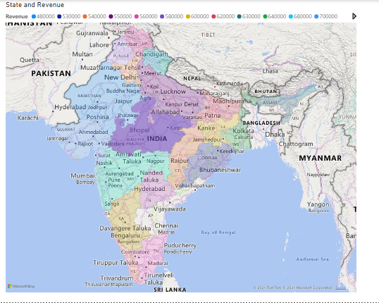

ii) Create a line chart to show the revenue based on the month of the year.

Line Chart for Monthly Revenue Trend
- Insert Line Chart:
  - Choose the Line Chart visual.
  - Add Date to the X Axis field, ensuring it's grouped by Month.
  - Drag Revenue into the Y Axis field.
- Format Line Chart:
- Go to the Format pane, adjust line thickness and color for better visualization.
- Add Data Labels if you want values displayed directly on the line.
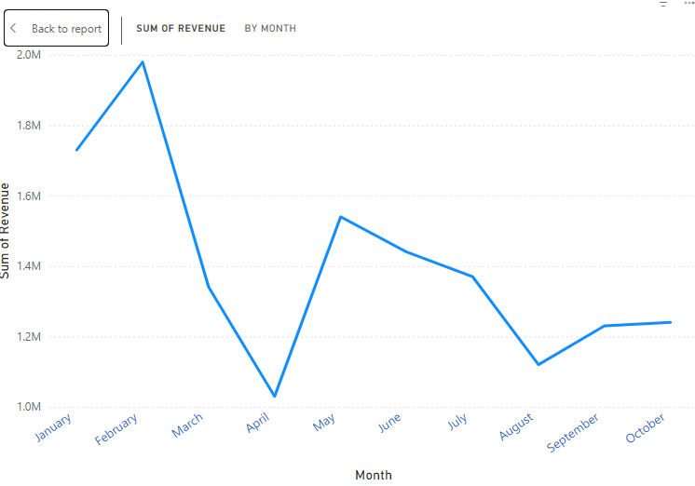

iii) Create a bin of size 10 for the age measure to create a new dimension to show the revenue.
Binning is a technique used to group continuous data into discrete ranges or categories, making it easier to analyze and visualize patterns in the data. In Power BI, binning is often applied to numerical fields like Age, Revenue, or Income to transform them into manageable intervals (or "bins").
For example, instead of analyzing individual ages in a dataset, you can create age bins such as 20-29, 30-39, and 40-49. This allows you to quickly see how different age groups contribute to total revenue, for instance, and spot trends that may not be obvious from looking at raw data.

Bin Revenue Data by Age (Bin Size = 10)
- Create Age Bins:
- Right CLick on Age->New Group->Set Bin size=10.
- Ensure Group type is Bin.
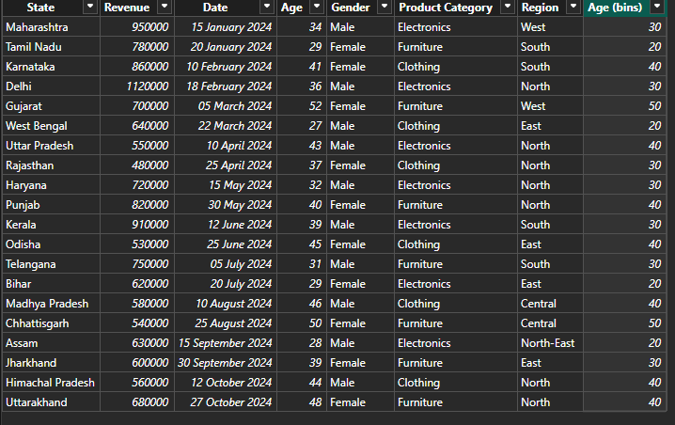
- Display Revenue by Age Bins:
  - Use a Bar chart(Clustered Column Chart) or other visuals to compare revenue across age groups.
  - Place "Age Bins" in the X-Axis and Revenue in the Y-Axis.

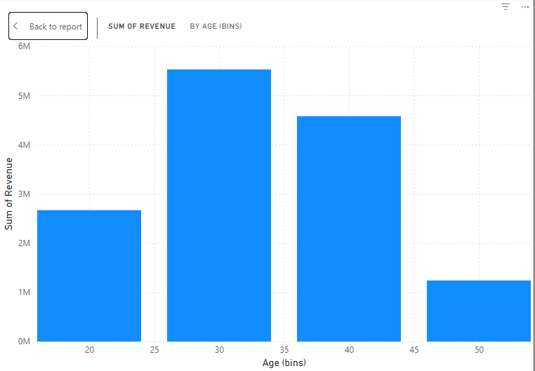

iv) Create a donut chart view to show the percentage of revenue per region by creating zero access in the calculated field.
Donut Charts
- A Donut Chart is a circular chart similar to a pie chart but with a hole in the center, creating a "donut" shape. It is used to show the proportional distribution of a whole by breaking it down into categories. Each segment of the donut represents a percentage of the total, allowing for easy comparison of parts to the whole.
- Donut charts are ideal for visualizing percentages or parts of a dataset (e.g., revenue by region) because they give an immediate sense of the relative size of each category. The empty center can also be used to display additional information, such as total values or key insights, making donut charts a compact and visually appealing option for comparing contributions across categories.

Step 1: Create a Calculated Field for Revenue Percentage

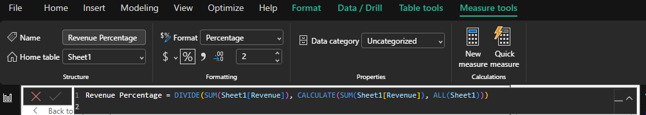
- Define the Measure for Revenue Percentage:
- Right click on Revenue field
- In the formula bar, enter the following formula to calculate the percentage of total revenue for each region.
- This formula calculates the revenue percentage for each region by dividing each region's revenue by the total revenue across all regions.

Revenue Percentage = DIVIDE(SUM(Sheet1[Revenue]), CALCULATE(SUM(Sheet1[Revenue]), ALL(Sheet1)))

- Format as Percentage:
- After creating the measure, go to the Measure Tools tab and set the format to Percentage so it will display as a percentage in the chart.

Step 2: Create the Donut Chart

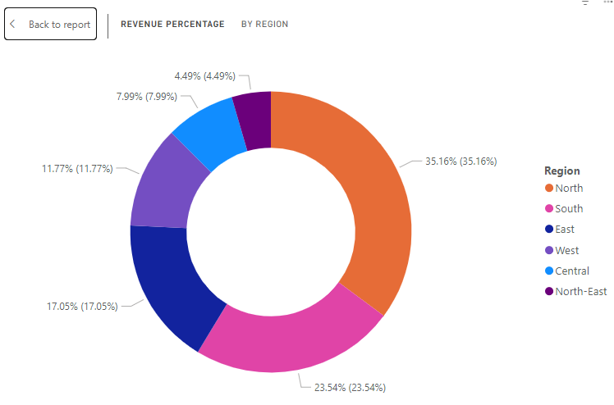
- Insert a Donut Chart:
  - Go to the Visualizations pane and select the Donut Chart icon.
  - Drag the Donut Chart visual onto your report canvas.
- Add Region to the Legend:
  - Drag the Region field into the Legend field well of the donut chart. This will separate each section of the donut chart by region.
- Add Revenue Percentage to Values:
  - Drag the Revenue Percentage measure you created into the Values field well.
  - This will make the donut chart display each region’s revenue as a percentage of the total.

v) Create a butterfly chart by reversing the bar chart to compare female & male revenue based on product category.
A Butterfly Chart (also called a Tornado or Divergent Bar Chart) is used to compare two categories side-by-side across a common variable, often to show differences between two groups. The chart consists of two bar charts placed back-to-back, resembling a butterfly's wings, which gives the chart its name.

Butterfly charts are popular for gender-based comparisons (like revenue by product category for male vs. female customers), age-group comparisons, or regional comparisons. Each side of the chart displays one of the two categories, helping visualize differences or trends between them across different variables or dimensions.

The below measure calculates the total revenue for rows where the Gender is Male and Female.

Right Click on Revenue Field in the Data Pane and Create a Measure for Male Revenue:

Male Revenue = CALCULATE(SUM(Sheet1[Revenue]), Sheet1[Gender] = "Male")

Similarly, Create a Measure for Female Revenue:

Female Revenue = CALCULATE(SUM(Sheet1[Revenue]), Sheet1[Gender] = "Female")

Step 2: Add the Measures to a Bar Chart for Comparison
- Insert a Clustered Bar Chart:
- In the Visualizations pane, select the Clustered Bar Chart (or Clustered Column Chart for a vertical layout) and add it to your report canvas.
- Add Product Category to the Axis:
- Drag the Product Category field into the X-Axis field well. This will be the common category along which you’ll compare Male and Female Revenue.
- Add Male and Female Revenue Measures to the Values:
  - Drag the Male Revenue measure into the Y-Axis field well.
  - Drag the Female Revenue measure into the Y-Axis field well as well.
  - The chart will now display side-by-side bars for Male and Female Revenue for each product category.
